**Name: _______________________________________________________ Date: ________________________________**

|  |
| --- |
| **Interventions Office**  Intervention Assistance Team (IAT) and Response to Intervention (RTI) |
| Participant Packet  Assessing School RTI Implementation |
|  |

|  |
| --- |
| **Staff will:**   * Understand the pillars of an effective Intervention Assistance Team (IAT) and how it facilitates the Response to Intervention (RTI) Process * Evaluate your current practice and develop goals for improvement * Better understand the RTI model |

**Do Now**

# Directions: We will watch a video entitled *Can you solve the bridge riddle?* by Alex Gendler. Work together as a team to solve the riddle. In addition, as you watch the video, consider the following questions:

# How do the individuals contribute to the success of the team?

# How might the video be characteristic of your school and the challenges you face?

# What is your “bridge?” Who are your “zombies?” Who are your “scientists?”

|  |
| --- |
| Note box: |

**Key Ideas**

* Every _______________ is important to the _______________ of the school and success of all students.
* _______________ fosters _______________ and _______________, especially the ability to _______________ to change.
* Schools are _______________ with many issues that individually may seem _______________. As a team, these issues can be _______________.

**Objectives and Agenda**

|  |  |
| --- | --- |
| Objectives | Agenda |
| * Determine next steps to improve your school’s RTI implementation Understand the pillars of an effective Intervention Assistance Team (IAT) and how it facilitates the Response to Intervention (RTI) Process * Evaluate your current practice and develop goals for improvement * Better understand the RTI model | Do Now  What is IAT and RTI?  Components of RTI – Expert and Jigsaw Groups  School Assessment  Gallery Walk  Final Personal and Group Reflections |

**What is IAT and RTI?**

**Directions:** As a team, you will work together to define key vocabulary for the IAT and RTI process using the HISD website and the *Texas Education Agency RTI Guidance App*. To complete this activity, several members of your team should download the app onto their smartphones.

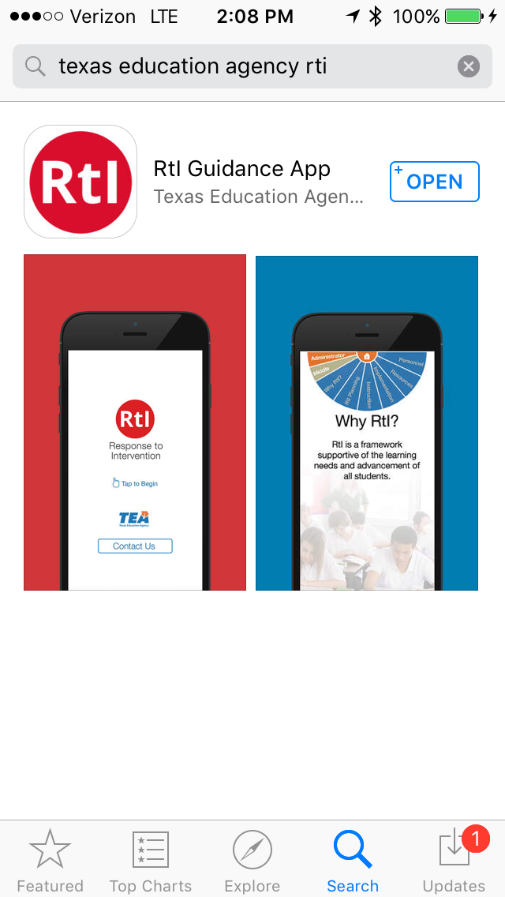 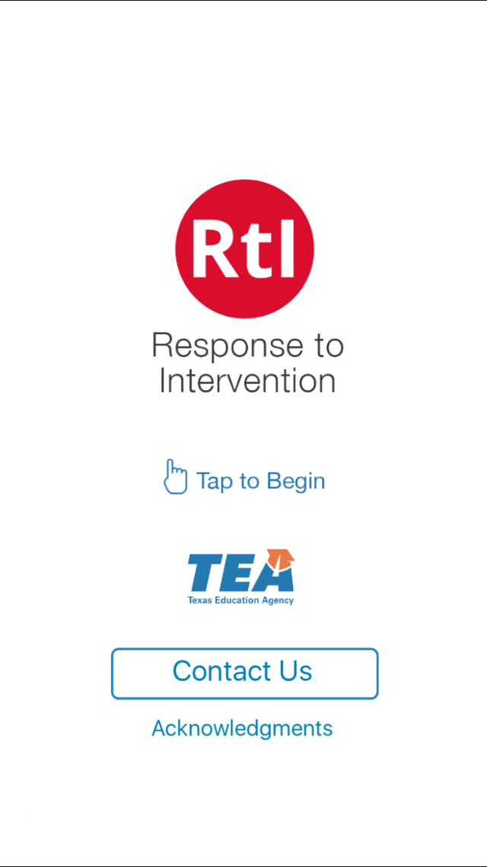

**Directions:** Using the HISD website (<http://www.houstonisd.org/Page/137095>) and the TEA RTI App and the chart below, define each key component of IAT and RTI. This activity is used to show your understanding of key terms related to the basics of IAT and RTI. Under the prediction column fill out what you believe the terms mean prior to the activity. As the terms are found and discussed during the activity add clarification to the final meaning column. Use the picture, sketch, example column to add additional clarifying information after the activity.

# *What Is IAT and RTI?* Vocabulary Chart

| Term | Prediction | Final Meaning | Picture/Sketch/Example |
| --- | --- | --- | --- |
| Intervention Assistance Team (IAT) |  |  |  |
| Response to Intervention (RTI) |  |  |  |
| Screening |  |  |  |
| Progress Monitoring |  |  |  |
| Multi-Level Prevention System |  |  |  |
| Data-Based Decision Making |  |  |  |
| Primary Level Prevention (Tier 1) |  |  |  |
| Secondary Level Prevention (Tier 2) |  |  |  |
| Tertiary Level Prevention (Tier 3) |  |  |  |

**Key Ideas**

* An Intervention Assistance Team (IAT) is a _______________ of professional educators with diverse _______________ and _______________ who convene to discuss and initiate _______________ for students in need of assistance and individualized services.
* The IAT team is a _______________-_______________ group whose purpose is to _______________ teachers, parents, and others with intervention strategies for dealing with the _______________ needs and _______________ problems of students.
* Response to Intervention (RTI) is a _______________-­­­­­­­­­­_______________ approach to the early identification and support of students with learning and behavior needs.
* The RTI process begins with high-quality _______________ and _______________ _______________ of all children in the general education classroom.

HISD RTI Framework

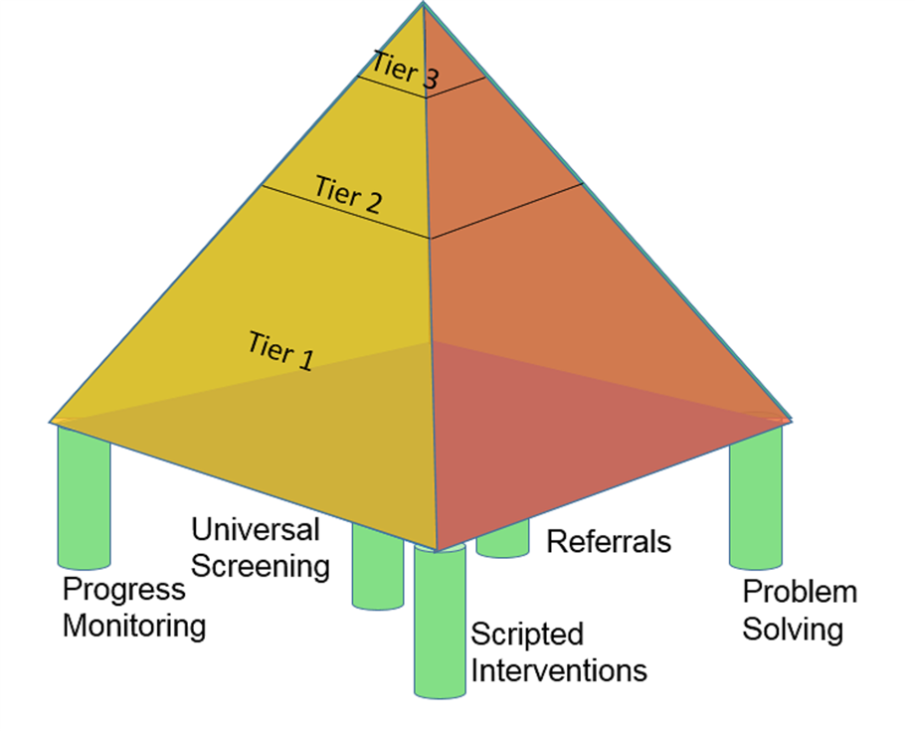

**Assessment of School’s Implementation of RTI**

***Expert Groups***

**Directions:** Count off to the number 7. Separate by numbers into groups around the room. As a group, read the *Center for Response to Intervention Fidelity of Implementation Rubric* for your section. Discuss the rubric and become an expert in your section. Be prepared to teach others the components of the rubric for your section. Use chart paper to highlight main points of that section.

|  |  |
| --- | --- |
| Group Number | Topic |
| Group 1 | Assessments |
| Group 2 | Data-based Decision Making |
| Group 3 | Multi-level Instruction: Tier I |
| Group 4 | Multi-level Instruction: Tier II |
| Group 5 | Multi-level Instruction: Tier III |
| Group 6 | Infrastructure and Support Mechanisms |
| Group 7 | Fidelity and Evaluation |

***Jigsaw Groups***

**Directions:** Reorganize into jigsaw groups with a number from 1-7. Choose one chart paper (rubric section) to begin. The expert from that section teaches the others in the group the information about each section as the group members take notes. Use the graphic organizer below to take notes of key details.

|  |  |
| --- | --- |
| Components of RTI | Key Details |
| Assessments |  |
| Data-based Decision Making |  |
| Multi-level Instruction: Tier I |  |
| Multi-level Instruction: Tier II |  |
| Multi-level Instruction: Tier III |  |
| Infrastructure and Support Mechanisms |  |
| Fidelity and Evaluation |  |

**School Assessment**

**Directions:** Based on the rubric, score your school’s implementation of RTI.

|  |  |  |
| --- | --- | --- |
| Components of RTI | Rubric Score | Recommendations for Improvement |
| Assessments |  |  |
| Data-based Decision Making |  |  |
| Multi-level Instruction: Tier I |  |  |
| Multi-level Instruction: Tier II |  |  |
| Multi-level Instruction: Tier III |  |  |
| Infrastructure and Support Mechanisms |  |  |
| Fidelity and Evaluation |  |  |

**Directions:** As a group, share and discuss your scores and recommendations. Use chart paper to record the top 5 recommendations from your group. List your group’s top 5 recommendations.

|  |  |
| --- | --- |
| Top 5 Recommendations for Schoolwide Implementation | |
| 1. |  |
| 2. |  |
| 3. |  |
| 4. |  |
| 5. |  |

**Gallery Walk**

**Directions:** As a group, conduct a gallery walk to review the recommendations from the other groups. Comment on the each group’s recommendations using words or symbols. After conducting the gallery walk, use energy dots to select your top 3 recommendations for implementation throughout the room. List your top 3 recommendations.

|  |  |
| --- | --- |
| Top 3 Personal Recommendations for Schoowide Implementation | |
| 1. |  |
| 2. |  |
| 3. |  |

**Final Personal Reflection**

**Directions:** As an individual, complete the 3-2-1 reflection questions below and be prepared to share with your table group.

List 3 key ideas discussed today that are strengths of the school.

|  |  |
| --- | --- |
| 1. |  |
| 2. |  |
| 3. |  |

List 2 key ideas discussed today that might be a personal challenge for you as an individual to assist in implementing a robust IAT process.

|  |  |
| --- | --- |
| 1. |  |
| 2. |  |

List 1 question you still have about RTI and your school’s implementation.

|  |  |
| --- | --- |
| 1. |  |

**Group Reflection**

**Directions:** As a table group, reach consensus on the 3-2-1. Record your group’s responses on chart paper to share with the whole group.

List 3 key ideas discussed today that are strengths of the school.

|  |  |
| --- | --- |
| 1. |  |
| 2. |  |
| 3. |  |

List 2 key ideas that might be schoolwide barriers to implementation of a robust IAT process.

|  |  |
| --- | --- |
| 1. |  |
| 2. |  |

List 1 question you still have about RTI and your school’s implementation.

|  |  |
| --- | --- |
| 1. |  |

**Campus Evaluation Specialist**

|  |
| --- |
| **Notes:** |

**Final Thought**

If you’re trying to achieve, there will be roadblocks. I’ve had them; everybody has had them. But obstacles don’t have to stop you. If you run into a wall, don’t turn around and give up. Figure out how to climb it, go through it, or work around it.

- Michael Jordan